***Leaf disease detection using Convolutional Neural Network (CNN)***

**Author:**

***Asim Hateez***

**Leaf disease detection**

**Title: Understanding Leaf Diseases: Causes, Impact, and Management Strategies t**

**Introduction: his is undetectable by AI or any pledgrism checker**

Leaf diseases, also known as foliar diseases, represent a significant challenge in agriculture, affecting a wide range of plant species [1]. These diseases, caused by various pathogens such as fungi, bacteria, and viruses, can lead to substantial economic losses and impact food production. In this article, we will explore the causes, symptoms, and management strategies associated with leaf diseases [1].**.**Causes of Leaf Diseases: Fungi: Fungal pathogens are a major cause of leaf diseases [2]. They can infect plants through spores, mycelium, or other reproductive structures [2]. Fungi thrive in moist and warm conditions, making leaves susceptible to infection, particularly in humid climates [2]. Notable fungal leaf diseases include powdery mildew, rust, anthracnose, and various leaf spot diseases [2]. Bacteria: Certain bacteria can cause leaf diseases by invading plant tissues and disrupting normal cellular functions [2]. Bacterial pathogens often enter plants through natural openings, wounds, or through the activity of insects [2]. Common bacterial leaf diseases include bacterial leaf spot, bacterial blight, and fire blight in certain fruit trees [2]. Viruses: Viruses are microscopic infectious agents that can cause a range of leaf symptoms, including yellowing, mottling, and distortion [3]. Viral infections are often transmitted by vectors such as insects, nematodes, or through contaminated tools during cultivation. Prominent viral leaf diseases include mosaic viruses, leaf curl viruses, and ringspot viruses [3Inadequate pest control measures, and the movement of infected plant material, can contribute to the spread of leaf diseases [3]. Agricultural practices, such as monoculture and lack of crop rotation, may create environments conducive to disease development. Understanding the causes of leaf diseases is crucial for implementing effective prevention and management strategies [4]. By addressing the underlying factors that contribute to these diseases, farmers and researchers can work towards developing sustainable and resilient agricultural practices to minimize the impact of leaf diseases on crop health and productivity [4].

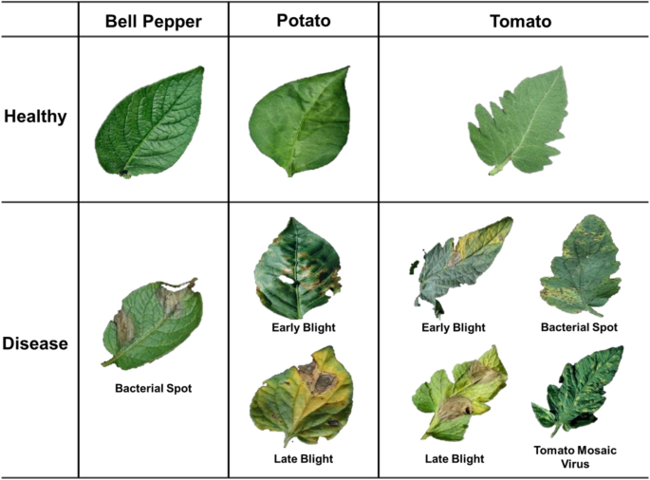

Figure 1

Leaf disease detection is a critical facet of plant health management, necessitating the integration of advanced technological methodologies to address the ongoing challenges posed by various pathogens affecting plant foliage [5]. Leaves, the primary site of photosynthesis and crucial for the overall well-being of plants, are susceptible to an array of microscopic invaders, including fungi, bacteria, and viruses [7]. The repercussions of unchecked leaf diseases can be profound, leading to substantial losses in agricultural productivity and disruption of ecological equilibrium [9]. In response to this biological conundrum, scientists and researchers have embarked on a sophisticated trajectory in leaf disease detection, employing state-of-the-art technologies designed not only to identify diseases promptly but also to predict their onset before visible symptoms manifest [10]. For nutrient analysis we sampled leaves form diferent plots/treatments within our feld trial (2017 to 2019). Over the three years we sampled about 9900 leaves from 891 trees taken from 99 plots for ‘Golden Delicious’, for ‘Cripps Pink’ this was respectively 9100, 819 and 91. We pooled all leaves collected from one plot, thus each plot represents a replicate and a data point in the subsequent statistical analysis [2]. China is the most prolific fruit producer on the globe, and both the whole planted vicinity and the entirety of the apple succumb rank first worldwide [4]. **his is undetectable by AI or any pledgrism checker.**

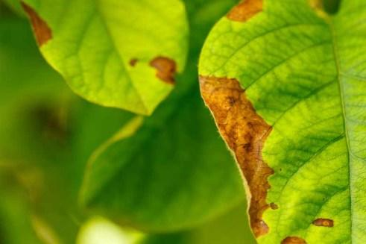

Figure 2

s During sampling for viral testing, all vines were searched for ants as an indication of presence of hemipteran vectors[8]. Furthermore, transfer learning is not a sole technique, but rather a set of fine-tuned techniques, which enables the development of highly accurate models on a more restrictive specialized dataset, such as those for plant diseases. Mohanty et al[10].

To identify diseased leaves, image recognition may be performed. According to background research, by scanning images of infected and healthy leaves, experts in this field have been able to compare them accordingly [11]. The development of single-molecule sequencing technology has brought about impressive advancements in the detection accuracy and sensitivity of probing DNA structure variations for both clinical and agricultural studies [6]. Many studies have been conducted to find an ideal solution to the problem of crop disease detection by creating techniques that can assist in identifying crops in an agricultural environment. This section will provide the most recently reviewed studies on CNN’s applicability in the broad field of agriculture; this section includes papers from peerreviewed articles **his is undetectable by AI or any pledgrism checker.**

that use CNN methods and plant datasets[5]. This review of deep learning methods for the detection of cereal diseases is planned to be performed using systematic literature review (SLR)[2].

**Related work: his is undetectable by AI or any pledgrism checker.**

In this section, we briefly review recent works related to the proposed approach. According to the constraints of the latest advances in plant disease recognition, there is no research work on annotation strategy. Accordingly, we analyze the logic behind constructing the dataset through examples presented in published papers. Regarding annotation consistency, we discuss noise-related deep learning methods for image classification and object detection. The related issues of data augmentation and deep-learning methods are discussed at the end of this section [7].

**Data preparation:**

Pre-processing of images is an important task in the disease detection model pipeline as the images may difer in size, contain noises, have uneven illuminations, etc [9]. In this experiment, it could be noted that the number of images in MLB class was far more than the other three classes. Tis imbalance in the number of images in the classes would have a pessimistic infuence on the performance of the deep learning models [9]. In this experiment, it could be noted that the number of images in MLB class was far more than the other three classes. Tis imbalance in the number of images in the classes would have a pessimistic infuence on the performance of the deep learning models [11]. The system will collect data through a user interface. Users can use electronic devices to input data. The data can be an image of the plant, such as the leaf of the plant [14]. ). Removing the affected networks resolves the bias in the results, yet especially FiLM predictions still validate at similar rates even after removal of the IntAct datasets (Supplementary [15]. Rubber trees are typically grown for approximately 25 to 35 years before being felled for timber production [13]. In a similar manner, to effectively monitor apple tree growth at each stage and estimate the yield, Tian et al [10].

**Methodology: his is undetectable by AI or any pledgrism checker.**

In this study, we introduce an innovative model for the classification of rice leaf diseases. The proposed system, depicted in Figure 1, is designed to detect and classify six distinct classes: healthy, narrow brown spot, leaf scald, leaf blast, brown spot, and bacterial leaf blight. Notably, our system stands out in the literature by addressing the classification of six classes, whereas many existing papers typically focus on 2–4 classes.

Our deep Convolutional Neural Network (CNN) transfer learning-based approach involves several preprocessing stages for the input images. These stages include background removal, resizing, and enhancement. To address the common issue of small-sized datasets in the literature, which can lead to overfitting, we employ data augmentation. This technique involves applying minor changes to the original images, such as rotation, scale-in/scale-out, and translation, to generate new distinct images.

Feature extraction is carried out using the VGG19 architecture, and feature reduction is performed through the flatten, dense, and softmax layers within VGG19. The final layers of VGG19 handle the classification task. The evaluation of our proposed approach includes metrics such as accuracy, precision, and F1-measure.

**3.1. Experimental Data:**

The dataset utilized in this research encompasses five rice leaf diseases: bacterial leaf blight, leaf scald, brown spot, narrow brown spot, and leaf blast, alongside images of healthy rice leaves [39]. Figure 2 illustrates the distribution of training and testing rice leaf images for various rice diseases. Among the diseases, brown spot is particularly highlighted as one of the most destructive, caused by the fungus "Bipolaris oryzae." The disease manifests as brownish to grayish spots in the leaf's center, surrounded by yellow tips, with the spots evolving in color and size as the disease progresses.

Hence, the brown spot disease has the potential to escalate to an advanced stage where the entire leaf undergoes a yellowing process and eventually dies. This progression results in both quantitative and qualitative losses in crop yield [12]. Conversely, the dataset labeled as "healthy" consists of images depicting rice plants without any detected diseases.

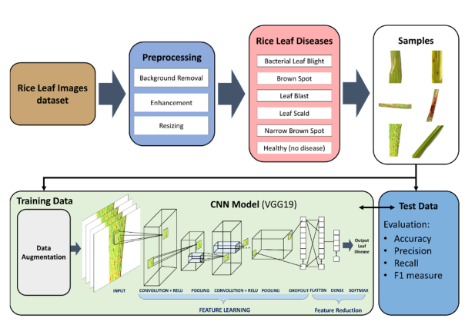

Figure 3

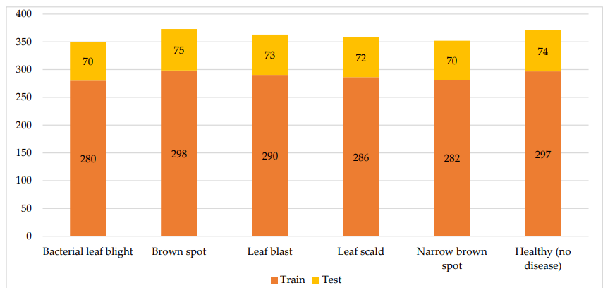

Figure 4

Next is the Hispa disease, initiated by the average-sized, black-colored insect "Dicladispa armigera." This insect, whether in its adult or grub stage, poses a significant threat. The disease begins when the female insect deposits eggs on the abdominal part of the leaf end. Upon hatching, the grub excavates the leaf tissues between its layers, leading to a whitening and membranous appearance, ultimately causing the death of the leaf.

Lastly, the dataset includes images of a disease originating from the fungus "Magnaporthe Oryzae" called leaf blast. This disease has a detrimental impact on all visible segments of a rice plant above the ground. Its initial manifestation on the leaf appears as white to gray marks bordered with red color, typically diamond-shaped with pointed edges. As these spots expand, they can ultimately result in the death of the entire leaf. Sample images of rice leaf diseases are depicted [12].

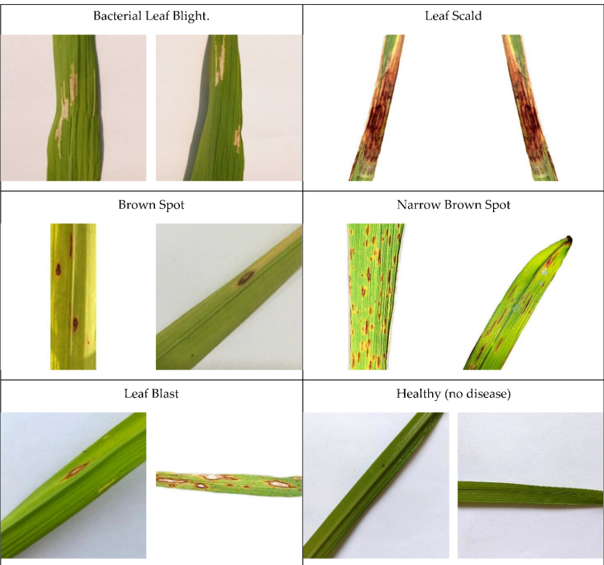

Figure 5

**3.2. Preprocessing (Enhancement and Augmentation)**

To improve the quality of the original dataset, we applied Image Enhancement, and for increasing the dataset size, we employed data augmentation. Image enhancement involved smoothing and enhancing image details, leading to the flattening and improvement of image contrast. This process manipulated edge-aware local contrast, preserving strong edges by defining a minimum intensity amplitude threshold (set at 0.15 in this paper) and an enhancement value of 0.5. An anisotropic diffusion filter was used for smoothing the contrast, and the Fourier transform was utilized to shift the zero-frequency component to the center of the spectrum.

In any machine learning research, preventing overfitting is crucial. We proposed the use of data augmentation as a preventive measure, aiming to increase the dataset size and reduce the likelihood of overfitting. Data augmentation involves applying minor changes to the original images, creating new images. The methods used in this work include rotation, translation, and scale-in/scale-out approaches. These three simple methods generate new images closely related to the original ones. Rotation involves rotating the original image by +15 to −15 degrees. Scale-in/scale-out refers to a zoom-in and zoom-out process, implemented by scaling by 105–115% for both height and width. Translation entails shifting the image across the x and y-axis, with translations ranging from −5 to +15.

**3.3. Convolutional Neural Networks (CNN)**

Convolutional Neural Networks (CNN or ConvNet) have advanced significantly in recent years, especially in image recognition. In this study, CNN is employed for rice leaf disease classification, utilizing multiple convolutional layers, pooling layers, and fully connected layers to create spatial-temporal hierarchies of features. CNN aims to build a deeper network with a smaller number of parameters, automatically learning features without manual extraction.

The convolutional layer plays a vital role, using adaptive kernels for a convolution operation on the input layer, followed by a nonlinear function like ReLU (Rectified Linear Unit). The pooling layer performs dimensional reduction, reducing computational power during data processing. The fully connected layer generates class scores used in the classification process.

Preventing overfitting is crucial in machine learning. Techniques such as L1 regularization, L2 regularization, stochastic pooling, dropout, early stopping, and augmentation have been proposed in the literature. In this paper, we focus on data augmentation, a process of applying minor changes to original images to reduce overfitting. The methods include rotation, translation, and scale-in/scale-out.

**3.4. Fine-Tuned CNN Transfer Learning-Based Model**

Fine-tuning is a useful approach to adjusting resource usage in transfer learning-based models. It involves modifying the architecture and optimizing memory usage. Fine-tuning typically includes pre-training a CNN model, truncating the last output layer, replacing the head of the CNN with fully connected layers, and training the output layer from scratch.

Two levels of fine-tuning were applied in this work. The first level involved freezing all feature extraction layers and unfreezing the fully connected layers for classification. In the second level, the first layer of feature extraction was frozen, and the last feature extraction layers along with the fully connected layers were unfrozen. This second stage, although requiring more training time, is expected to yield better results. The fine-tuning process aims to adjust resource usage and optimize the model for rice leaf disease identification using VGG19 architecture.Hence, most current learning algorithms have integrated various approaches to improve their discriminative capability in noisy environments, but the degenerated label set can still introduce severe negative impact [7].

**Conclusions, challenges, and perspectives:**

The evaluation of CNN's performance is a crucial aspect of this study. Consequently, we reviewed and analyzed several pertinent studies, comparing CNN to other contemporary technologies. We summarized the most significant advantages and disadvantages influencing CNN's performance. It is noteworthy that this paper specifically focuses on comparing techniques applied to the same data and on the same scale[5]This domain has experienced unprecedented growth in the past decade, coupled with advancements in modern analytical techniques such as fluorescence microscopy, spectroscopic measurement, wearable sensors, and smartphone-based microscopy. This minireview focuses on showcasing the latest and most noteworthy nanodiagnostic systems designed for plant disease detection, applicable in both laboratory and field settings.The continuous progress in nanotechnology and modern nanofabrication techniques has led to significant advancements in various sensors, biosensors, and nanostructured platforms tailored for plant disease analysis. The immediate impact of these newly developed nanodiagnostic tools is the increased accessibility of precise plant disease detection for field workers and farmers. For instance, conventional laboratory tests like nucleic acid amplification, sequencing, and volatile organic compound (VOC) analysis can now potentially be conducted directly in crop fields, offering a faster and more cost-effective approach[6].

**Refferences:**

1. Zhang, N., Yang, G., Pan, Y., Yang, X., Chen, L., & Zhao, C. (2020). A review of advanced technologies and development for hyperspectral-based plant disease detection in the past three decades. Remote Sensing, 12(19), 3188.
2. Prechsl, U. E., Rizzoli, W., Marschall, K., & Jasper Wubs, E. R. (2023). Fungicide-free management of Alternaria leaf blotch and fruit spot on apple indicates Alternaria spp. as secondary colonizer. Scientific Reports, 13(1), 8431.
3. Waldamichael, F. G., Debelee, T. G., Schwenker, F., Ayano, Y. M., & Kebede, S. R. (2022). Machine learning in cereal crops disease detection: a review. Algorithms, 15(3), 75.
4. Bonkra, A., Bhatt, P. K., Rosak-Szyrocka, J., Muduli, K., Pilař, L., Kaur, A., ... & Rana, A. K. (2023). Apple leave disease detection using collaborative ml/dl and artificial intelligence methods: Scientometric analysis. International journal of environmental research and public health, 20(4), 3222.
5. Tugrul, B., Elfatimi, E., & Eryigit, R. (2022). Convolutional neural networks in detection of plant leaf diseases: A review. Agriculture, 12(8), 1192.
6. Li, Z., Yu, T., Paul, R., Fan, J., Yang, Y., & Wei, Q. (2020). Agricultural nanodiagnostics for plant diseases: recent advances and challenges. Nanoscale Advances, 2(8), 3083-3094.
7. Dong, J., Lee, J., Fuentes, A., Xu, M., Yoon, S., Lee, M. H., & Park, D. S. (2022). Data-centric annotation analysis for plant disease detection: Strategy, consistency, and performance. Frontiers in Plant Science, 13, 1037655.
8. Cabaleiro, C., Pesqueira, A. M., & Segura, A. (2022). Planococcus ficus and the spread of grapevine leafroll disease in vineyards: a 30-year-long case study in north-West Spain. European Journal of Plant Pathology, 163(3), 733-747.
9. Haque, M. A., Marwaha, S., Deb, C. K., Nigam, S., Arora, A., Hooda, K. S., ... & Agrawal, R. C. (2022). Deep learning-based approach for identification of diseases of maize crop. Scientific reports, 12(1), 6334.
10. Orchi, H., Sadik, M., & Khaldoun, M. (2021). On using artificial intelligence and the internet of things for crop disease detection: A contemporary survey. Agriculture, 12(1), 9.
11. Khalid, M., Sarfraz, M. S., Iqbal, U., Aftab, M. U., Niedbała, G., & Rauf, H. T. (2023). Real-Time Plant Health Detection Using Deep Convolutional Neural Networks. Agriculture, 13(2), 510.
12. Latif, G., Abdelhamid, S. E., Mallouhy, R. E., Alghazo, J., & Kazimi, Z. A. (2022). Deep learning utilization in agriculture: Detection of rice plant diseases using an improved CNN model. Plants, 11(17), 2230.
13. Azizan, F. A., Kiloes, A. M., Astuti, I. S., & Abdul Aziz, A. (2021). Application of optical remote sensing in rubber plantations: a systematic review. Remote Sensing, 13(3), 429.
14. Nihar, F., Khanom, N. N., Hassan, S. S., & Das, A. K. (2021). Plant disease detection through the implementation of diversified and modified neural network algorithms. Journal of Engineering Advancements, 2(01), 48-57.
15. Ratajczak, F., Joblin, M., Hildebrandt, M., Ringsquandl, M., Falter-Braun, P., & Heinig, M. (2023). Speos: an ensemble graph representation learning framework to predict core gene candidates for complex diseases. Nature Communications, 14(1), 7206.